Teemu Jääskeläinen
teemu.jaaskelainen@gmail.com

Project Old Birds 2.0 Unity Script overview (Updated 23.8.2015)

Camera (Old birds 1.0)

The game is using the OrtoCamScript.cs for the 2.5D camera. The camera is attached into an "Eye socket", which makes it easier to move the camera (like moving an eye in an eye socket). The script is simple and the main function is to let the user move the camera and scroll in and out in the scene. There's a variable to make it possible to lock the scrolling for debug purposes.

Main controller and the waypoint system (Old birds 2.0)

The moving functionality of the game characters is coded in to the MainController.cs. The main controller starts the movement of Marjatta-bird according to the name of the scene. The movement is started with individual co-routines. It's made this way for if the programmer wants to, for example, hide the characted in the beginning of the scene and make it visible few seconds later, like it's implemented currently in the Oulu_city scene. The script needs to have a parent gameobject and it's children (each named with Waypoint(n), i.e. Waypoint1, Waypoint2 etc.) to move the character. The waypoint system starts from the first waypoint and ends with the last waypoint in the parent gameobject. It is possible to place a gameobject with a trigger collider and a SceneTrigger.cs attached to change the scene when a bird touches it. It's used in the Marjattas_house and Oulu_city scenes. There is also a simulation for the phone call answers in the main controller.

Random waypoint movement (Old birds 2.2.x)

Random movement was added to simulate random behaviour of the senior citizens. Below picture demonstrates the technicalities of the random waypoint system.

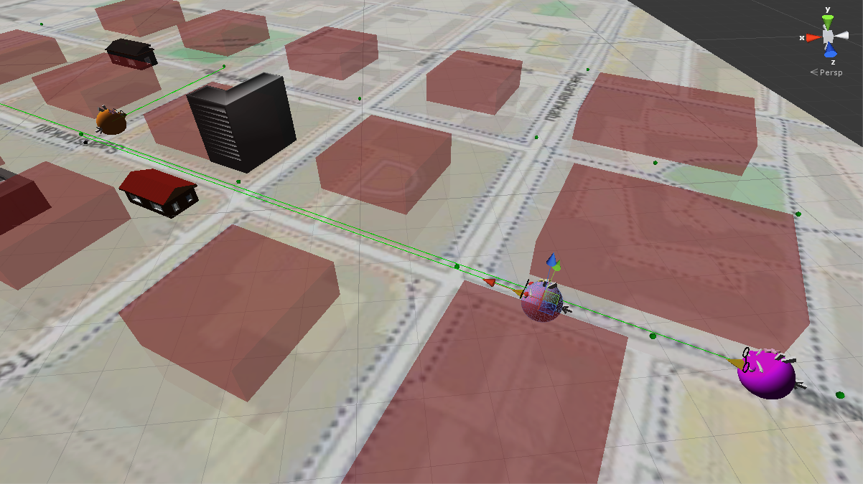

The green dots are gizmos (indicators that won’t show in the game view) that represent the waypoints in the same manor than the dedicated waypoints, excepts that they are shown as green, not black. The birds movements are randomized through these waypoints. The red boxes are gizmos for areas that the birds can’t walk through. The randomizer casts a ray between the birds and a new waypoint, and if the red area is between these two points, a new ray will be cast until it finds a waypoint where the bird can walk to.

You can either decide the bird to have its determined path or randomize it from the editor controls.

Time simulation (Old birds 2.2)

It is possible to control the simulated time in the old birds environment. You can either pause, forward, fast forward, reverse or fast reverse time with the available controls. Reverse and forward buttons sets the time to go 1x the normal real time speed, whereas the double reverse and fast forward buttons doubles the current simulated speed (you can double it multiple times).

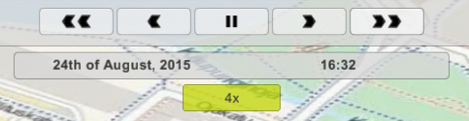

The time simulation is currently tied to the birds and the calendar system.

The calendar system and distributed database (Old birds 2.2)

The calendar was designed to be as intuitive as possible, so I decided to copy much of its style from the google calendar. One can create, modify or delete events in it. The calendar is made with the new Unity UI system (different than the Old Birds 2.0 caregiver GUI, which is going to be deprecated in some future).

Implementing the calendar prefab can be troublesome because of it’s many dependencies, so try to be patient and take examples from scenes Oulu_city and Bus scenario. Other scenes are not made for the calendar UI or the time simulation yet.

The calendar uses a simple distributed database through a handful of PHP interface commands. You can find the database script from the database folder. Note that you can’t use the calendar in its current state if the db.php is not on a running server, and the authorization information is not set correctly in both, /scripts/Web/SQLHandler.cs on the local machine and the db.php in the remote (or local, if you will) server.

Also, the database have to be up and running on the server with this description:

Table name: events

Name | Type | Alphabetical | Can be empty | Default value | Info
event_id | int(11) |  | No | None | AUTO_INCREMENT
start_time | time |  | No | None
end_time | time |  | Yes | NULL
date | date |  | No | None
location | varchar(20) | utf8_unicode_ci | No | None
activity | varchar(20) | utf8_unicode_ci | No | None
reminder | int(11) |  | No | None

Bus trip scenario (Old birds 2.2)

The bust trip scenario (a simple scenario where most of the birds navigate to the bus, and the bus leaves on a certain time), is implemented with the OB2.0 waypoint system. The bus is animated with the Unity animator and does not use any waypoints.

Information boxes (Old birds 2.2)

Individual birds have individual information about them. Old birds 1.0 introduced a simple hovering text on the birds when the mouse was over them, but it was a broken and clumsy system, so I decided to make a new system to show information about the birds.

By clicking a bird and then the “info” or “information” button on the upper left corner, opens up a dialog that show three different important information of the selected bird:
- Current status (what is it doing)
- Next event (what is it going to do)
- Information (Illnesses and notes)

GUI script and the caregiver interface system (Old birds 2.0)

The graphical user interface (GUI) scripting is mostly in the CaregiverGUIScript.cs. It was the main task for the project to construct a communication tool for the caregiver. With this tool the caregiver can contact the senior through calling, multicalling, texting and multitexting. The GUI is controlled through the states in CaregiverGUIStates enumerator:

CaregiverGUIStates.MAIN is used to show the main "menu" to the user. The menu includes the birds that are selected with the SelectionTool.cs, and two simple buttons to make a call or a text message.

CaregiverGUIStates.CALLING state gives a signal to the main cotroller that the caregiver is calling to senior(s), which then stops the birds after three to nine seconds. During this time, the CaregiverGUIScript.cs draws a speech bubble with three dots on the birds(s). When this state is on and the call is finally answered, the script moves to the CaregiverGUIStates.CALLING_ANSWERED state.

CaregiverGUIStates.CALLING_ANSWERED is responsible of popping up the senior UI, where the user can see the caregivers avatar. The state also changes the speech bubble of the bird(s) to indicate that the call is ongoing.

CaregiverGUIStates.CALL_ENDED state is simply informing the script that the call has ended and the bird(s) can continue moving after a short delay. Because if the similiar functionality, this state is also used when the back button of the texting interface is clicked.

CaregiverGUIStates.TEXTING is used to show the texting interface of the caregiver communication tool. The interface consists of the space for messages, text sending button, message box and a back button. The text messages are stored in to an array to show them and later review them if needed. The text messages are marked with a prefix, so the caregiver and senior messages are shown witha separate background.

CaregiverGUIStates.TEXT_SENT_NOT_NOTICED works in similiar way thatn the CaregiverGUIStates.CALLING state. When the caregiver has sent a text message to the senior, a speech bubble is popped up on the bird(s), indicating of a new text message, and in few seconds the senior(s) notice the message and the state is changed to CaregiverGUIStates.TEXT_NOTICED.

CaregiverGUIStates.TEXT_NOTICED pops up a similiar texting interface for the senior. Messages written here are shown with a differend color background than the messages of the caregiver.

MAIN
CALLING
CALLING_ANSWERED
CALL_ENDED
TEXTING
TEXT_SENT_NOT_NOTICED
TEXT_NOTICED
CALL_ENDED
CAREGIVER GUI STATES

